www

**Assignment Documentation on** **AWS**

**VPC PEERING**

Dated 20-12-2022

By - Ritesh

**AWS VPC Peering**

A VPC Peering connection is a networking connection between two VPCs that enable you to route traffic between them using private IPV4 addresses or IPV6 addresses

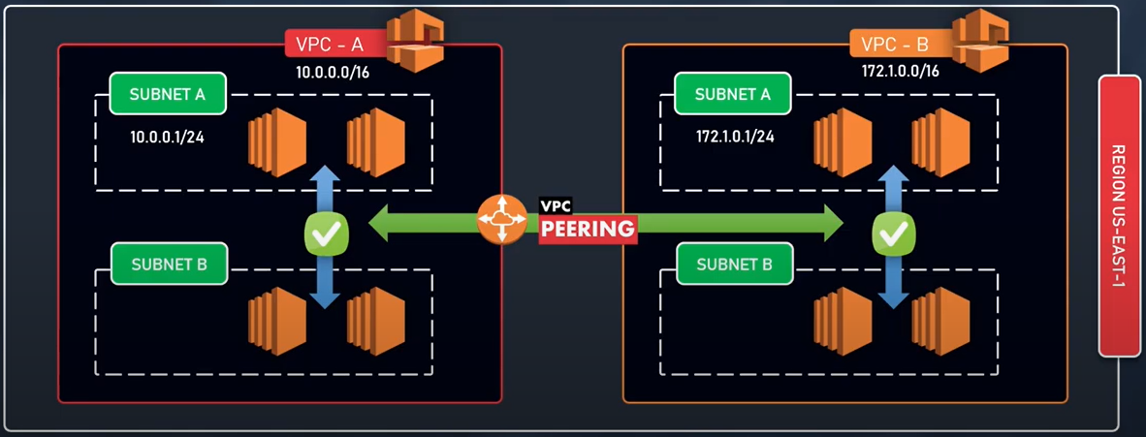

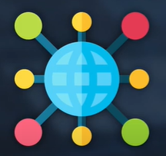 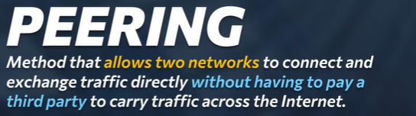

AWS uses the existing infrastructure of a VPC to create a VPC peering connection:

* Sharing data across accounts become easier.
* Sharing data across instance across vpc becomes easier.
* We can establish peering relationship between VPCs across different AWS Regions (also called Inter-Region VPC Peering)
* Can communicate with EC2, RDS, Lambda without needing:
* Gateways
* VPN connections
* Separate network appliances.
* All traffics remains in the Private IP space.

**MULTIPLE VPC PEERING CONNECTION**

It is a One -To- One relationship between 2VPC.

There is no support for TRANSITIVE relationships or connections.

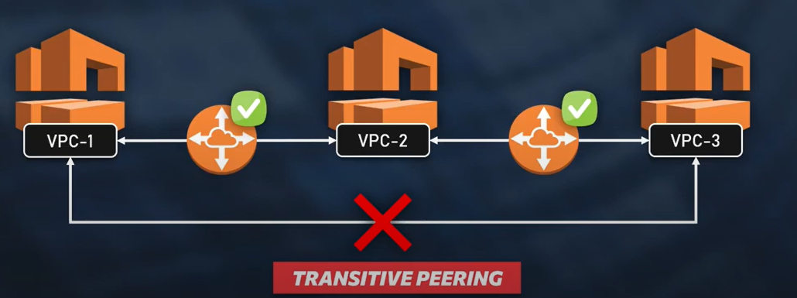

**VPC** PEERING (Points to Remember)

1. You cannot create a VPC peering connection between VPCs that have matching or overlapping IPV4 or IPV6 CIDR blocks.

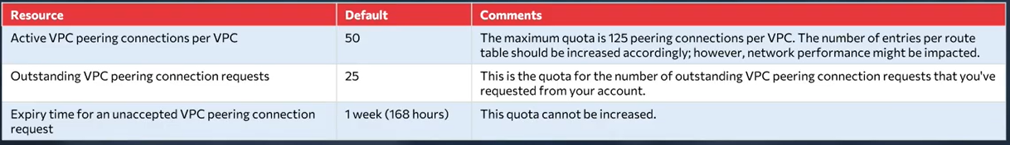

1. VPC peering does not support transitive peering relationships.
2. You cannot have more than one VPC peering connection between the same two VPCs at the same time.
3. Any tags that you create for your VPC peering connection are only applied in the account or region in which you create them.
4. You cannot connect to or query the Amazon DNS server in peer VPC.

